Poecilia reticulata Female Mating Preference Based on Male Colouration
Mariam Munyi, Andrea Castro, Domenico Comita, Tanner Schilling

BIOL 3100 – Intro to Animal Behaviour
Thompson Rivers University
November 15th, 2024

INTRODUCTION
Guppies (Poecilia reticulata) are small fish that orginate from freshwater streams in northern South America but are now widespread (Vallie 2023). These fish are sexually dimorphic: the females and males have different physiological and behavioural characteristics. For example, the length of females range from 3 to 7cm while males are 1.5 to 4cm. Male guppies have a distinct anal fin—the gonopodium—that is nonexistent in females (Dick et al. 2018). Guppies are a relatively timid species compared to others like the beta fish (Sanders 2023). Mate selection is a critical aspect of guppy evolution as females tend to prefer males with distinct feature like (Brooks et al. 2014). For guppies, mate choice is often influenced by behaviour, size, and colour. Female guppies prefer male characteristics tied to both reproductive success and survival (Dugatkin and Godin 1996).
Male coloration is essential to female guppy mate choice (Dugatkin and Godin 1996; Hanke and Hoade 1997). Guppies display various bright colours, including orange, yellow, and blue, and females tend to prefer males with vibrant hues (Sanders 2023). This preference has driven sexual selection, producing more colourful male guppies over generations (Godin and McDonaugh 2003). Previous studies have shown that bright coloration signals good health, boldness and the ability to evade predators, making these males more attractive to females (Dugatkin and Godin 1996). Further research suggests that orange is a crucial indicator of male fitness in guppies, as it is linked to higher levels of carotenoids and correlates with boldness, measured by a male's willingness to risk approaching predators without being killed. This increases their fitness as they are more likely to survive encounters with predators (Godin and Dugatkin 1996).
Many studies have sought to understand which vibrant colours male guppies display are preferable to females. A critical study by Hank and Houde in 1997 focused on the colour preference of female guppies on male guppies from Trinidad's Yarra and Paria rivers. The researchers discovered that Yarra and Paria females preferred orange males similarly, although male guppies from the Paria River generally display orange coloration (Hanke and Houde 1997). This suggests that factors beyond the local availability of orange males, such as potential environmental pressures or other selective forces, may drive the preference for oranges. This study is significant because it demonstrates that female guppies prefer the colour orange across guppy populations in different locations (Hanke and Houde 1997).
This study aims to investigate the mating preferences of female guppies based on the coloration of male guppies. Previous research has shown that female guppies prefer males with bright, vibrant colours, particularly orange (Dugatkin and Godin 1996). For example, studies have indicated that female guppies from different populations consistently choose orange males over others, suggesting a potential preference for this coloration in mate choice (Hanke and Houde 1997). Building on these findings, we hypothesize that female guppies will prefer orange-coloured males over males with a yellow or blue coloration. Specifically, we predict that when female guppies are presented with male guppies of orange, yellow, and blue coloration in the same tank, they will spend significantly more time near the orange males.

METHODS
We prepared a five-gallon fish tank previously housing guppies by removing the heater, temperature gauge, and water pump while keeping the layer of gravel. Using a sharpie, we divided the tank into three sections. Each section measured 21.7 cm long and 13.2 cm wide. These guppies were bought from the local pet store and before the trials, the guppies were placed in the backrooms. The female and male guppies were kept in separate five-gallon fish tanks.
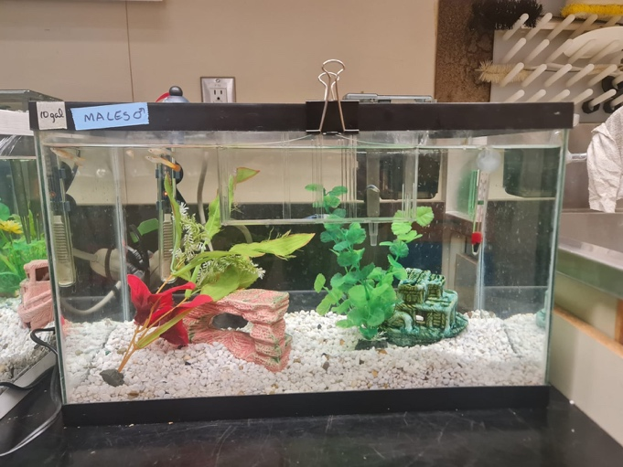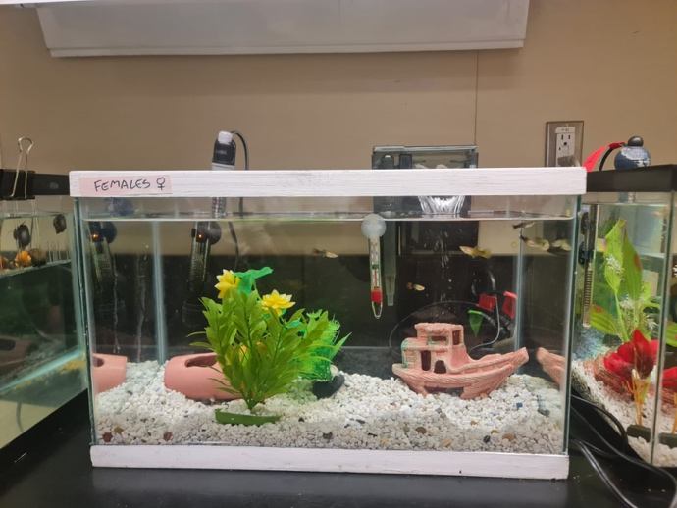Figure 1. Male and female guppies were housed in separate 10-gallon fish tanks before trials. The male guppies were housed in the tank on the left, while the female guppies were housed in the tank on the right.

A glass bowl transferred Five female guppies into the lab testing area. To transport and contain the male guppies, we used three 600mL beakers. One beaker held three orange males, another held three yellow males, and the third contained three blue males. The beakers were placed upside down in the tank and arranged from left to right: yellow, orange, and blue.
We introduced five female fish to the tank individually, allowing each twenty seconds to acclimate to the new environment. Each fish was then observed for five minutes, during which we recorded the time spent in each section of the tank using a conventional stopwatch and a phone stopwatch app. The experiment was repeated twice, each time with a different arrangement of the male guppies: first in the blue-yellow-orange sequence and then orange-blue-yellow. Additionally, we measured and recorded each female's size using a 1 x 1 cm grid and noted each fish's coloration through visual observation.

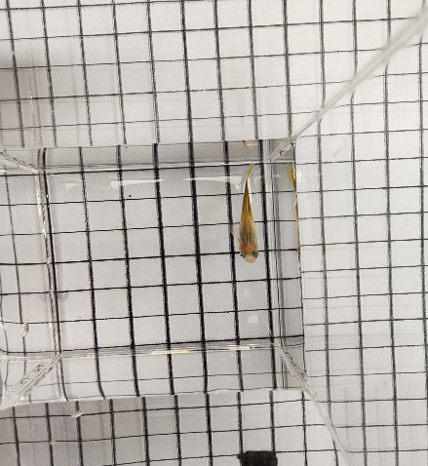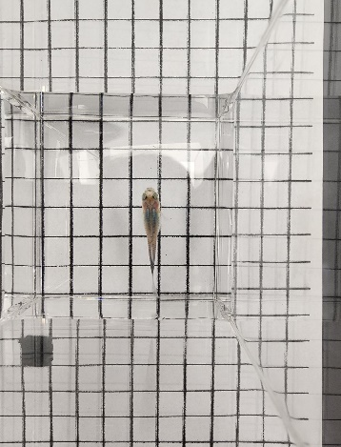
Figure 2. Female guppies are measured using a 1x1 cm grid. The guppies were measured when their straight body lined up well with the squares.
We repeated the same steps the next day of trials, testing five new females with the same conditions and experimental setup. The trials were conducted over two weeks. We used ten female guppies and three orange, three blue, and three yellow male guppies.

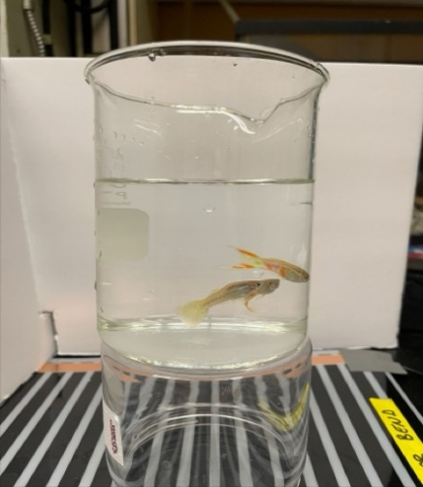 | 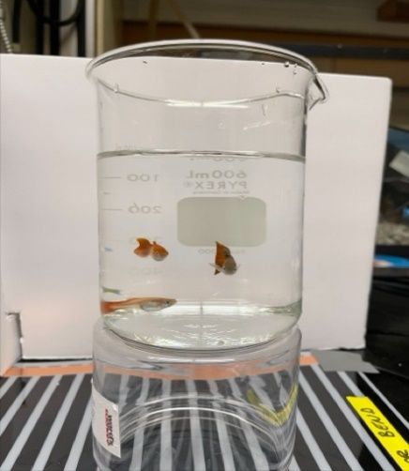 | 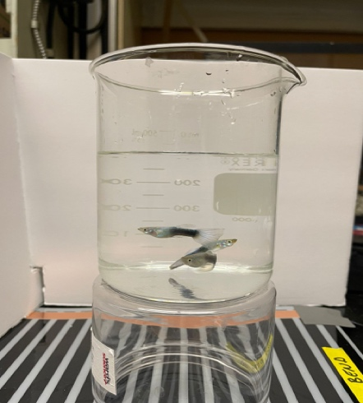
Figure 3. Three 600ml beakers containing (left to right) three yellow male, three orange male and three blue male guppies. These beakers were used to transfer and place the male guppies within our experimental tank.
We conducted statistical tests using JASP with our raw data to evaluate differences in the female guppies' mating preference based on colouration. We first performed an ANOVA test to examine differences in the time the female guppies spent with the different-coloured male guppies. Additionally, we used an ANOVA test to analyze differences in the amount of time the female guppies spent in each of the different regions of the tank. Finally, we conducted a t-test to compare the two variables with the highest variance for both time spent with each specific male coloration and time spent in certain tank zones.

RESULTS
The female guppy's length in this experiment was, on average, 3.41±0.15cm. We found no significant difference in the female's length, giving us no reason to test further if length affected their colour preference.
This experiment showed only a significant colouration preference between orange and blue male guppies. Figure 4 shows the preference for male colouration by the female guppies, showing a wide variation in the time spent with each colour. You can extrapolate that the females spent the most time on average with the orange guppies (111.58 seconds), then the second most time with the yellow males (105.55 seconds), and the last time with the blue guppies (84.90 seconds).
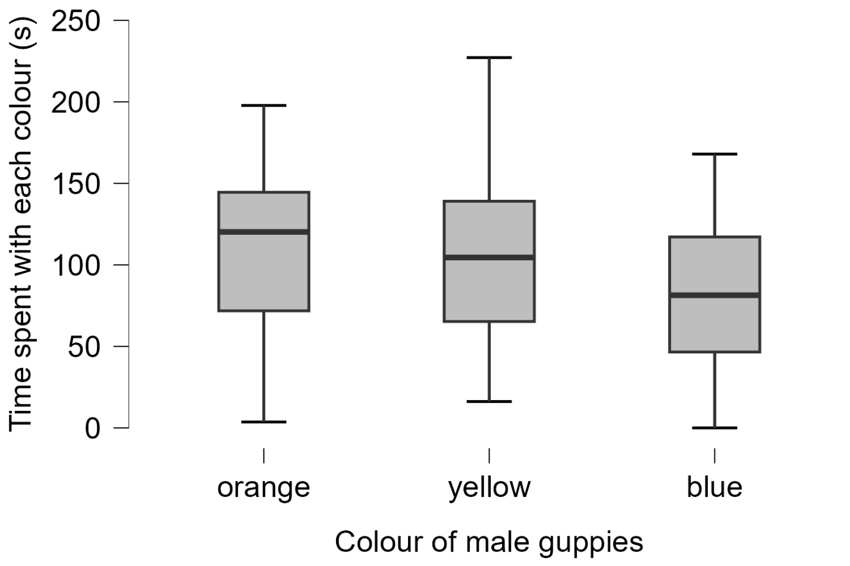
Figure 4. Time spent by female guppies with each colour of male guppies over 5-minute trials (n=10).

In Table 1, we obtained a p-value of 0.108 and an F value of 2.285 from our ANOVA test of female time spent with each colour. Having an F value more excellent than 1 indicates more variation between the colours than within, prompting the need for t-tests between the different colours.

Table 1. Anova test results of time spent by female guppies with blue, yellow, and orange male guppies.
Cases |  | Sum of Squares |  | df |  | Mean Square |  | F |  | p
Colour of male guppies |  | 11745.914 |  | 2 |  | 5872.957 |  | 2.285 |  | 0.108
Residuals |  | 223623.106 |  | 87 |  | 2570.381

We performed a t-test between all the colours, only finding a significant difference between the time spent with orange males and blue males, as seen in Table 2. We obtained a p-value of 0.034, telling us the female guppies significantly spent more time with the orange than the blue male guppies. Between orange and yellow, we obtained a p-value of 0.667, and the t-test between yellow and blue had a p-value of 0.11
Table 2. T-test between the time spent by the female guppies with the orange compared to blue male guppies.
 |  | t |  | df |  | p
Female time spent with orange compared to blue male guppies |  | -2.167 |  | 58 |  | 0.034

During our experiment, we found that the females preferred specific locations of the tank over the colour of the male guppies presented. We found the female guppies spent significantly more time in the middle of the tank (132.56 seconds) than on either side, as seen in Figure 5. The guppies also spent more time on the right side (101.72 seconds) than the tank's left side (67.74 seconds).
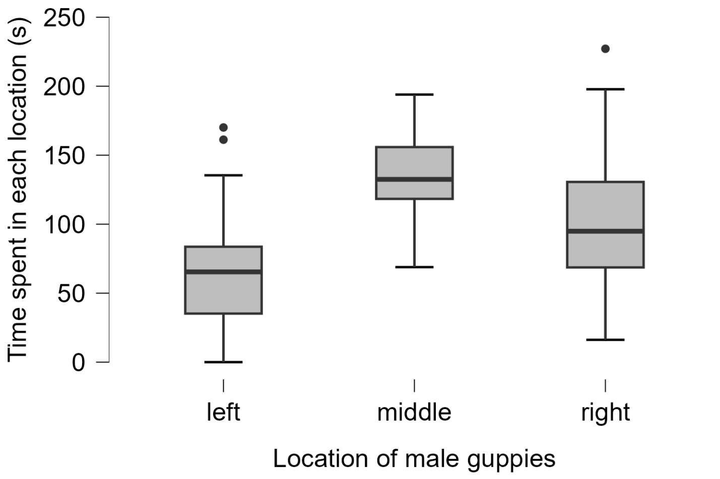
Figure 5. Time spent by female guppies in each tank location (n=10).

We found a significant difference in time spent in each location by the female guppies from an ANOVA test, seen in Figure 3. Obtaining a p-value < 0.001 and an F value of 15.93 meant a significant difference in preference between the three locations.

Table 3. Anova test results of time spent by female guppies in the different locations of the tank (left, right, and middle).
Cases |  | Sum of Squares |  | df |  | Mean Square |  | F |  | p
Location of male guppies |  | 63075.479 |  | 2 |  | 31537.739 |  | 15.925 |  | < .001
Residuals |  | 172293.542 |  | 87 |  | 1980.386

We performed t-tests between the time spent on the tank's left and right side and between the tank's right and middle. We found a significant preference for the middle of the tank over the right side, having a p-value of 0.011, as seen in Table 4. Table 5 shows the t-test results from the time spent on the right side of the tank compared to the left; we obtained a p-value of 0.010. The female guppies also spend significantly more time on the right side then the left side of the tank. Since the right side of the tank had a higher average time spent than the left (101.73 seconds compared to 67.74 seconds), we found a significant difference between the time spent on the left and right sides. We can state that the female guppies significantly spent more time in the middle than on the right and left sides of the tank.
Table 4. T-test results of time spent by female guppies on the left side of the tank compared to the right side.
 |  | t |  | df |  | p
Female guppy time spent in the left compared to right side of the tank |  | 2.639 |  | 58 |  | 0.011

Table 5. T-test results of time spent by female guppies on the right side of the tank compared to the middle.
 |  | t |  | df | p
Female guppie time spent in the middle compared to the right side of the tank |  | -2.657 |  | 58 | 0.010

DISCUSSION
The results of our study on female guppy mating preferences based on male coloration align with previous research, reinforcing the idea that male coloration plays a significant role in mate selection. The results indicate that, on average, females spent the most time with orange-coloured males, 111.58 seconds, suggesting a preference for this coloration. The second-highest average was for yellow males, with 105.55 seconds, and the lowest was for blue males, with an average of 84.90 seconds. This supports earlier studies by Dugatkin and Godin (1996) and Houde (1997), highlighting the importance of orange coloration in male guppies as a signal of fitness and attractiveness to females.
Although female guppies generally preferred orange males, the results did not reveal a statistically significant difference in the time spent with orange versus yellow males. This suggests that while orange coloration may be more attractive overall, yellow males also possess traits that appeal to females. Similarly, there was no significant difference between the time spent with yellow and blue males, further highlighting the complexity of female mate preferences. These findings suggest that female guppy preferences may not be driven by colour alone but could also be influenced by other factors, such as selective pressures from predators.
We did, however, find a significant difference between the time female guppies spent with orange males and blue males, with blues being less favoured. This comparison's significant p-value (p = 0.034) highlights females' strong preference for more vibrant or carotenoid-rich colours like orange due to evolutionary advantages linked to mate selection. Due to these results, based on coloured choice, we failed to reject the null hypothesis.
Regarding the females' behaviour within the tank, the results showed that they spent significantly more time in the middle section (132.56 seconds) compared to the left and right sides. This might be due to the tank's setup or the arrangement of the male guppies, where females may have been more inclined to spend time in the center to assess all the males more effectively. The significant difference between the time spent in the middle versus the right side (p < 0.05) and the right versus the left side also suggests that females might have preferred zones in the tank, which could have influenced their mate choice behaviour.
This study allows us to observe firsthand female preferences for differently coloured male guppies, enhancing our understanding of the sexual selection and mate choice in this species. It demonstrates how female preferences for male coloration can drive the evolution of specific traits, serving as a foundation for future research. The insights gained provide valuable knowledge that other researchers can apply to different species and theories of natural selection.
To improve future experiments, we could rotate tank positions to control for lighting and angle bias. Further, we could allow females a more extended acclimatization period and consider using a triangular tank (if testing one female guppy preference between three different coloured males) or testing two colorations simultaneously. Future studies could be conducted in larger, more naturalistic environments to enhance ecological relevance, explore additional male traits beyond colour, and increase the sample size to better capture variability within the population.
Overall, our study confirms the significant role of male coloration in female guppy mate selection, particularly the strong preference for orange-coloured males. This aligns with Dugatkin and Godin's (1996) and Houde's (1997) research. While females favoured orange males over blue, the lack of significant difference between orange and yellow, or yellow and blue, suggests factors beyond colour influence mate choice. The preference for the tank's middle section highlights the need for careful experimental design. Future studies should address these limitations by using more naturalistic environments, controlling tank bias, and exploring additional male traits to deepen our understanding of sexual selection.

References
Bisazza A, Evans JP, Pilastro A, Simonato M. 2004. Cryptic Female Preference for Colorful Males in Guppies. Evolution. 58(3):665–669. doi:https://doi.org/10.1111/j.0014-3820.2004.tb01690.x.
Brooks RC, Head ML, Ingleby FC, Lindholm AK, Rollins LA, Zajitschek SRK. 2014. Causes of male sexual trait divergence in introduced populations of guppies. Journal of Evolutionary Biology. 27(2):437–448. doi:https://doi.org/10.1111/jeb.12313.
Dick C, Reznick DN, Hayashi CY. 2018. Sex-biased expression between guppies varying in the presence of ornamental coloration. PeerJ 6. 10.7717/peerj.5782
Dugatkin LA, Godin JG. 1996. Female mating preference for bold males in the guppy, Poecilia reticulata. Proceedings of the National Academy of Sciences. 93(19):10262–10267. doi:https://doi.org/10.1073/pnas.93.19.10262. https://www.pnas.org/content/pnas/93/19/10262.full.pdf.
Godin J-GJ, McDonough HE. 2003. Predator preference for brightly colored males in the Guppy: A viability cost for a sexually selected trait. Behavioral Ecology 14:194–200. 10.1093/beheco/14.2.194
Hanke MA, Houde AE. 1997. Evolutionary mismatch of mating preferences and male colour patterns in guppies. Animal Behaviour. 53(2):343–351. doi:https://doi.org/10.1006/anbe.1996.0399.
Sanders J. 2023 Nov 15. Guppy Fish Species Profile. The Spruce Pets. https://www.thesprucepets.com/guppy-fish-species-profile-5078901.
Vallie S. 2023 January 4. What to Know About Guppies. WebMD. https://www.webmd.com/pets/what-to-know-about-guppies.

