Campus Engagement Between International and Domestic Students at TRU

Domenico Comita and Zach Bullock

Biol 3000_01: Biometrics
Professor: Dr. Emily Studd
December 6, 2023

INTRODUCTION

In the winter semester of 2023, Thompson Rivers University (TRU) students accounted for over 14% of the Kamloops population (Thompson Rivers University Factbook 2023; World Population Review 2023). With a student body exceeding 14,000 students, TRU hosts a substantial international presence, with approximately 36% of the student body consisting of students from outside of Canada (Thompson Rivers University Factbook). The demographic landscape has shifted notably, witnessing a 25% increase in international student numbers from 4,173 in 2021-2022 to 5,255 in 2022-2023 (Thompson Rivers University Factbook 2023).
Given this evolving composition, our research seeks to understand the dynamics of campus engagement between international and domestic students at TRU. Given the significant presence of international students at TRU, we aim to explore potential differences in campus engagement between international and domestic students. Building on existing research indicating that first-year international students attending university in Canada prioritize the social aspect of university life, we seek to determine whether these patterns hold true for TRU students (Brophy et al. 2022). Notably, prior research suggests that first-year international students express greater intentions for campus engagement than their domestic counterparts (Brophy et al. 2022).
Financial considerations also emerge as a factor in the examination of campus engagement between international and domestic students, with international students at TRU paying over four times more than their domestic counterparts (TRU Tuition and Fee Details). While this discrepancy is comparatively modest when compared to larger Canadian universities like UBC and UofT, it prompts us to investigate whether financial investment influences the levels of engagement in on-campus activities among international students (Comparative International Education 2023).
This leads us to the central question: Does one's place of origin influence participation in campus engagement activities at TRU? As we delve into this question, we encountered findings from a 2008 study that suggesting an overall similarity in CE levels between international and domestic students (Edwards 2008). Conversely, a study from 2018 by Ohio State University indicates higher campus involvement among domestic students (Student Life Survey 2018). In the context of TRU, however, we propose a different trend. The university offers diverse programs, such as initiatives like the Leisure Exploration Activity Program (LEAP). The LEAP program, most prominently advertised to international students, facilitates increased student engagement in community activities and events ((LEAP, n.d.). Our hypothesis posits that if the place of origin affects campus engagement levels, and we measure the levels of campus engagement between international and domestic students, that international students will exhibit higher participation.
Moreover, the social challenges faced by international students, including difficulties in forming "Canadian friendships" due to language barriers, may drive them towards clubs and intramural teams as avenues for social integration (CBIE Research in Brief 2016; Telbis et al. 2014). Both domestic and international students can further foster connections through participation in intramural sports teams and fitness classes (Telbis et al. 2014).
Students at TRU also have the chance to attend sports games and conferences, both of which are indicative of increased levels of campus engagement (Boulton et al. 2019). Furthermore, the university offers a diverse array of clubs, with 107 registered in the TRU Student Union club directory, presenting another avenue for international students to connect with peers (Club Directory TRUSU 2020). In summary, our study aims to provide insight into the dynamics of on-campus engagement at TRU, exploring the influence of place of origin on students' participation in various activities.

METHODS AND MATERIALS

DATA COLLECTION
Data was collected using surveys made in Google Forms. The criteria for participants to participate in the study was that they were TRU students taking their classes on campus. This is so that we don’t have students who have a full online course load skewing the data by not being engaged in campus activities due to not being on campus. The surveying took place between the dates of October 25th, 2023, through November 16th, 2023. Surveys were circulated to TRU students through active in-person interactions where we asked if the student would like to become a participant, if they said yes, a QR code was shown to the participant that led them to the survey. We reached out to professors at the university and three classes were shown the QR code and offered the opportunity to participate in the study. We also posted posters with a summary of the study and a QR code around the TRU campus to try and attract more participants.
The survey that was used contained questions so that participants could be put into categories, and some could be filtered out. The most important preliminary questions asked were whether the participant was an international student which was defined as a non-Canadian resident attending TRU or a domestic student which was defined as a Canadian resident attending TRU. The question of whether the participant was a full-time student which is defined as a student who is enrolled in 9 or more credits in the Fall 2023 semester was asked so that we could filter out any part-time students as they may have more free time in comparison to full-time students at TRU, meaning they have more time for campus activities. Other questions that were asked that could be used to categorize participants, but that were not necessarily used in this study were: Year of study, Indigenous descent, program of study, age category, employment status, and whether they have dependents.

CAMPUS ENGAGEMENT METRICS
Six main questions were used to measure engagement levels in the participants of the study, and they were all scored depending on the level of commitment each activity requires. The first question asked was “ How many clubs are you involved in at TRU”, participants could choose from the following options: none, 1, 2, 3, 4, or 5+. Each club that a participant was involved in constituted two points on the scoring scale, being involved in one club would equal two points while being involved in five or more clubs would equal ten points. The next question looked to see if participants were involved in any recreational activities, the ones that could be chosen were intramural sports, drop-in sports, fitness classes, and none. Participants could choose more than one option, and each option was worth 1 point.
Conference attendance was measured by asking the participant “How often do you attend conferences or listen to speakers at TRU?” the options were: always, most times, sometimes, or rarely. The same ranking system was used for “How often do you attend TRU sports games/events” which always equals 2, most times is 1.5 points, sometimes is 1 point and rarely is 0.5 points. The final two questions were both yes or no questions, the first being “Are you part of the LEAP program at TRU?” which if yes was selected equaled 2 points, and finally “Do you play on a TRU sports team” which if yes selected equals 1 point. The six categories outlined above represent most of the campus engagement activities available on the TRU campus for students.

STATISTICAL ANALYSIS
Data collected was exported to an Excel file where it was further formatted to make sure that all answers collected from the survey had a numeric value. The sum of the total level of campus engagement was calculated for each participant. This data was then imported into R Studio.
The main statistical analysis completed for this study was that of creating a boxplot with student type (International and Domestic) on the x-axis and the sum of campus engagement on the y-axis. A t-test was also completed using this same data to determine if there is a significant difference between campus engagement in international students compared to domestic students. Multiple statistical tests were done to better understand campus engagement at TRU, because looking at all these stats is accurate but answers a broad question. A t-test and bar graph were completed to illustrate the individual survey answers for most of the categories individually. This was done to look at the finer details of the study and see if there is anything else that could be learned from this data.

RESULTS
The investigation into campus engagement levels between international and domestic students at TRU reveals intriguing insights. According to the two-sample t-test that we ran, there was no significant difference in the overall level of campus engagement between international and domestic students (t204.26=1.7051, 0.05<p<1.00). The mean international student campus engagement score was 2.87963 and the domestic student campus engagement score was 2.40250 (Fig.1).
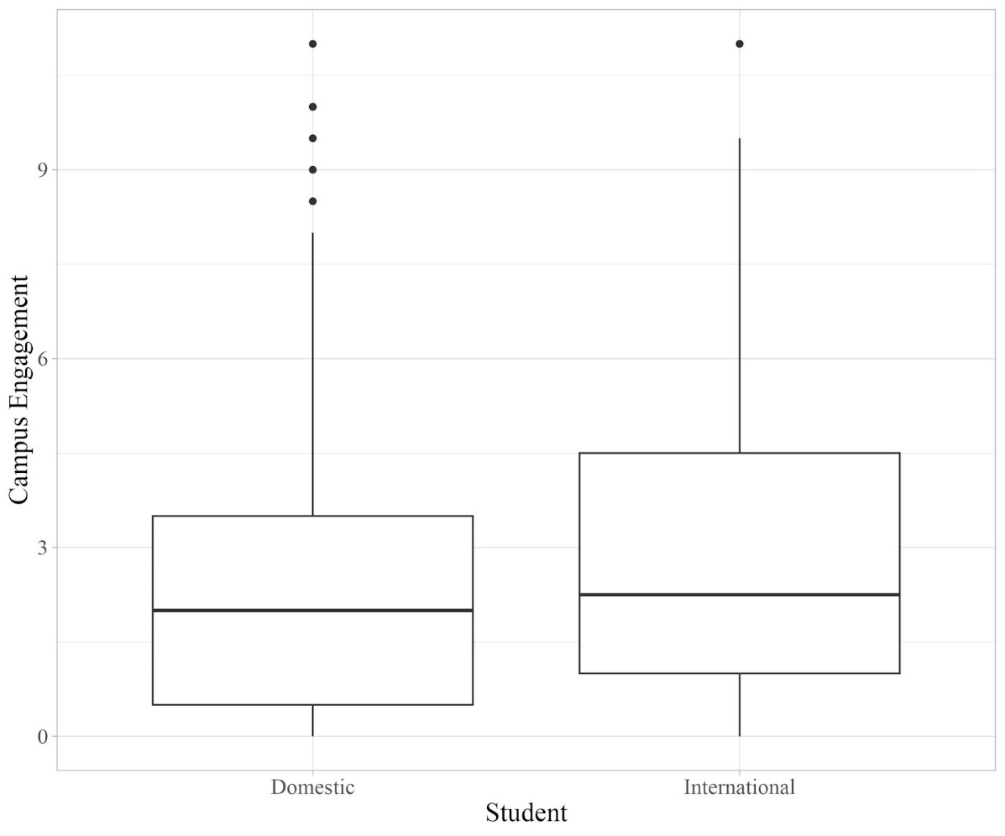
Figure 1. Difference in campus engagement between domestic students and International students at TRU. Results were gathered from surveying international students (n=108) and domestic students (n=200).
The t-test ran for LEAP participation in domestic and international students showed a significant difference in levels of engagement (t113.63=5.2009, p<0.0001). The mean international student engagement score for LEAP was 0.444, and the mean domestic student engagement score was 0.020 (Fig. 2).
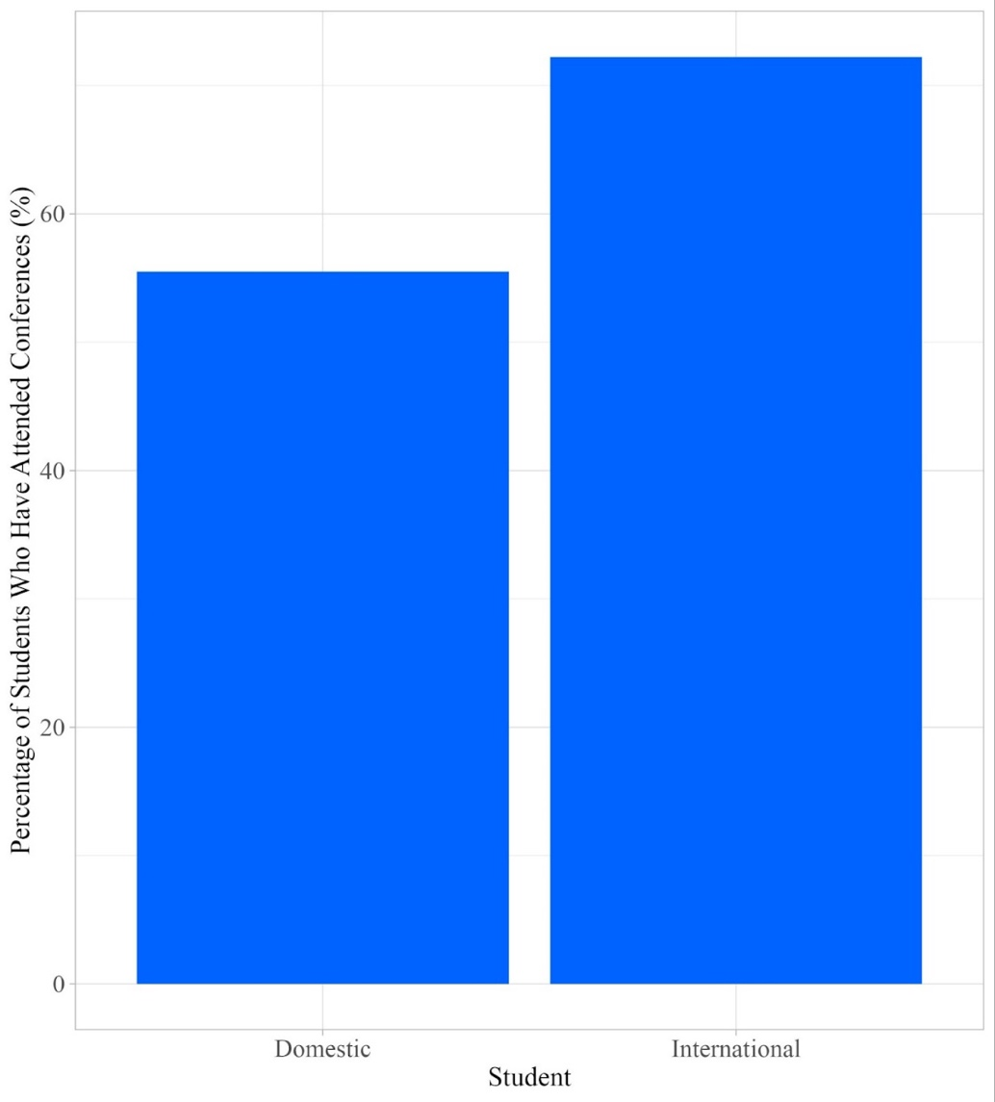

Figure 2. Percentage of Domestic student and International students participation in the LEAP program at TRU. Results were gathered from surveying international students (n=108) and domestic students (n=200).

A t-test showed a significant difference in the level of sports team engagement between domestic and international students (t287.25=-2.15, p<0.05). The mean sports team engagement score for domestic students was 0.25 and for international students, it was 0.111 (Fig. 3).
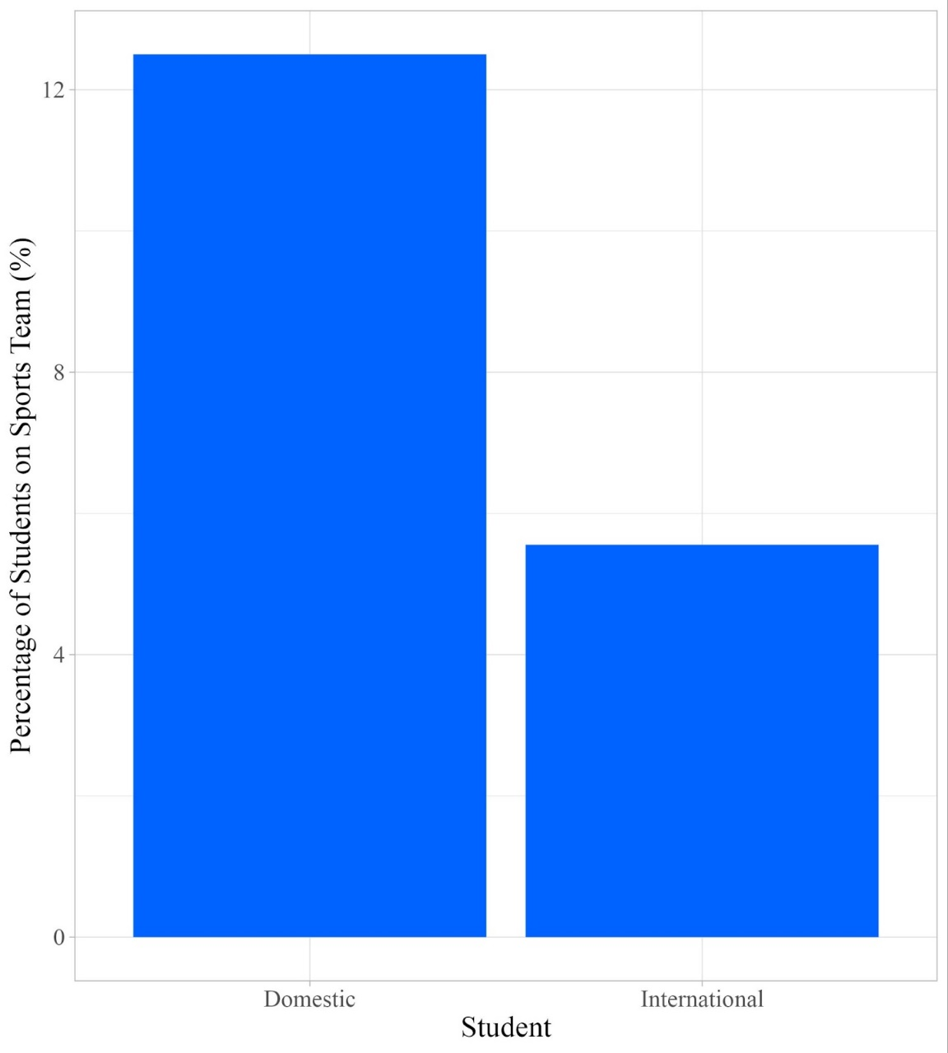

Figure 3. Percentage of Domestic students and International students participation in TRU sports teams. Results were gathered from surveying international students (n=108) and domestic students (n=200).

The t-test showed a significant difference in the club engagement level between international students and domestic students (t171.52=3.103, p<0.01). The mean club participation score for international students was 1.5 and 0.81 for domestic students (Fig. 4).

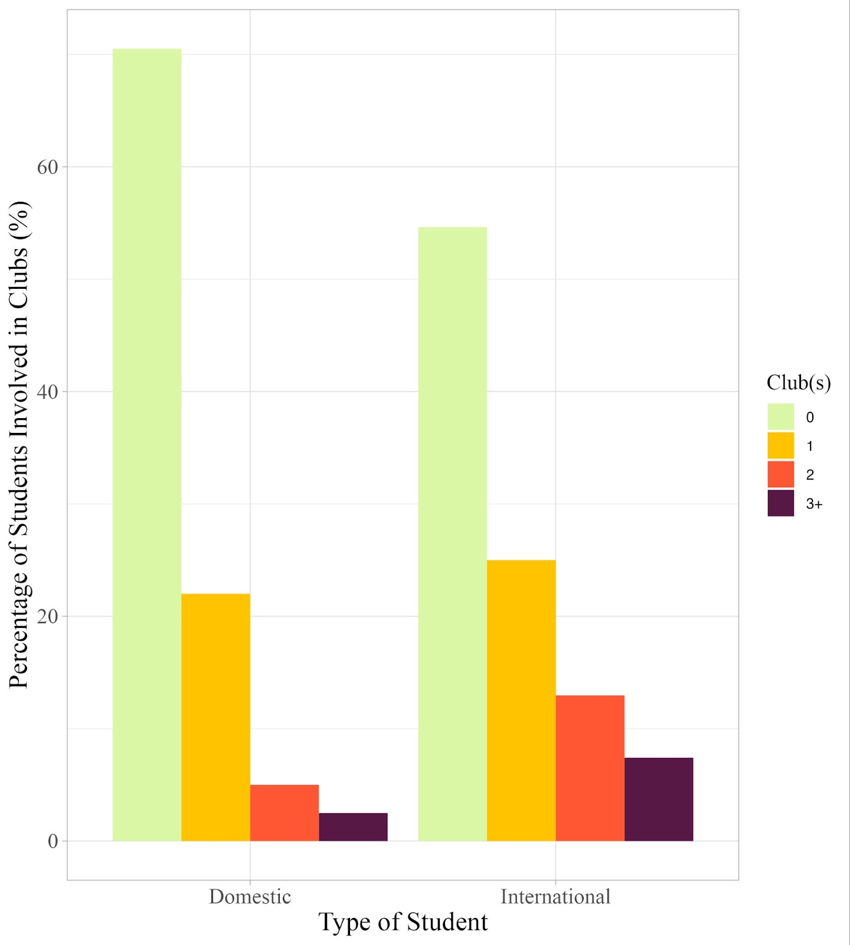
Figure 4. Club participation in Domestic students and International students at TRU. Results were gathered from surveying international students (n=108) and domestic students (n=200).
A t-test showed that there is a significant difference in the levels of attendance at conferences between international and domestic students (t191.7=3.55, p>0.001). The mean conference attendance score for international students was 0.634 and 0.412 for domestic students (Fig. 5).

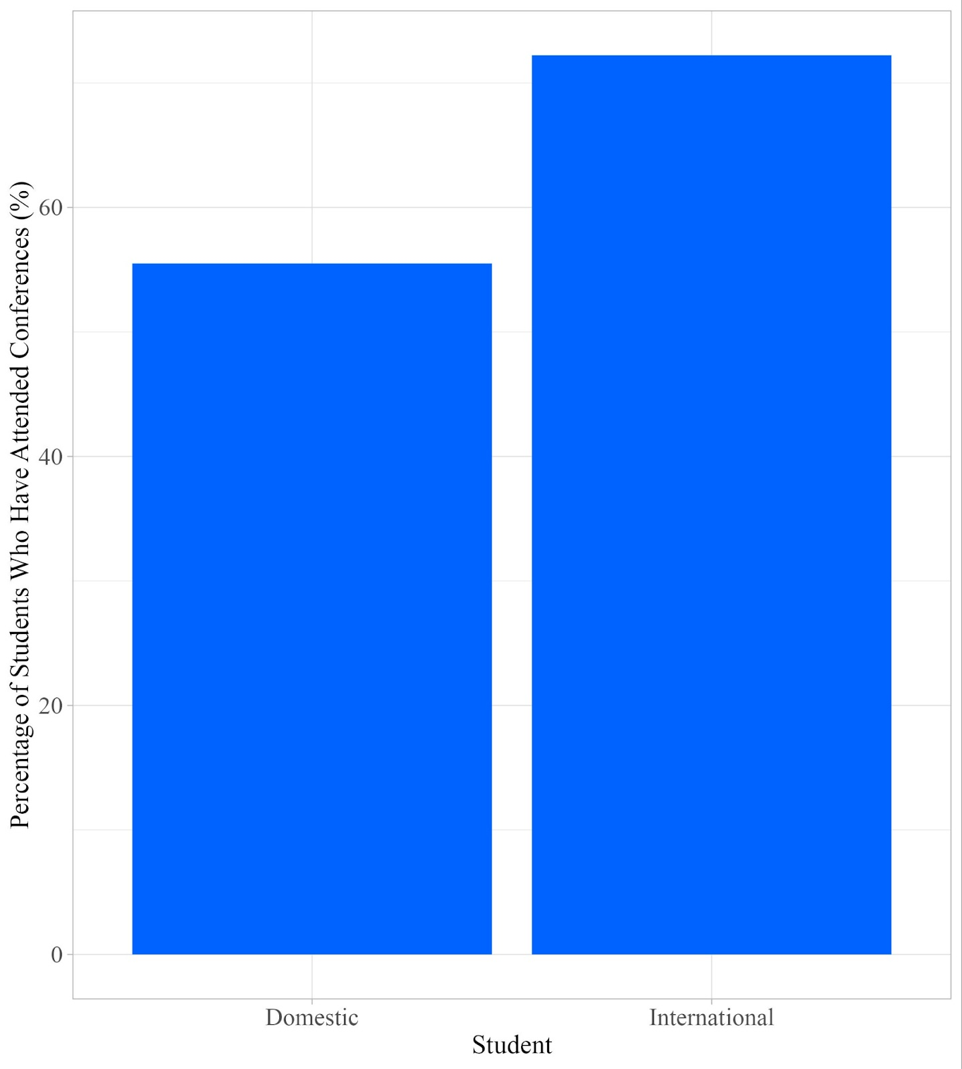
Figure 5. Percentage of domestic and international who have attended a conference. Results were gathered from surveying international students (n=108) and domestic students (n=200).
A t-test showed that there was not a significant difference in levels of participation in recreational activities at TRU between international students and domestic students (t167.75=1.24, 0.05<p<1.00). The mean score of recreational activity participation for international students was 0.388 and 0.290 for domestic students (Fig. 6).
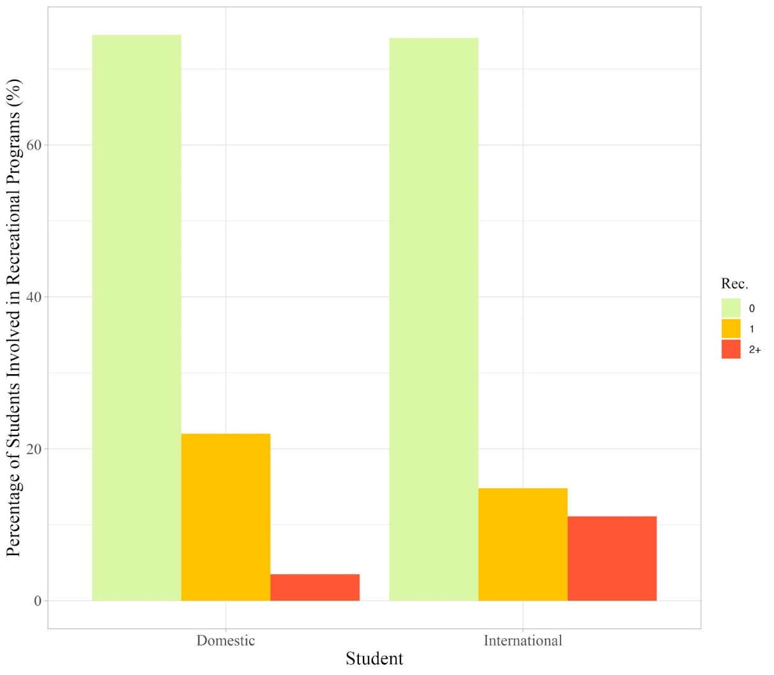
Figure 6. Level of participation in recreational programs at TRU in domestic students and international students. Shows the percentage of domestic students (n=200), and international students (n=108) who participated in 0, 1, or 2+ of the following activities: Drop-in sports, intramurals, and fitness classes.

A t-test was also done for sports game attendance. This t-test showed that there is a significant difference in the levels of attendance at TRU sports games between international and domestic students (t277.38=-1.076, p>0.05). The mean sports game attendance score for international students was 0.620 and 0.551 for domestic students.

DISCUSSION AND CONCLUSION
Our results were able to show us how the levels of campus engagement between international students and domestic students differ at TRU. We found that overall, there is not a significant difference in campus engagement between international students and domestic students, but when looking at the individual categories that were asked about in the surveys there is lots of variation in engagement depending on the specific activity or program. This answers the original question of whether there is a difference in the level of campus engagement between domestic students and international students. Based on the data we collected, there is not a statistically significant difference in the levels of campus engagement between international and domestic students at TRU (t204.26=1.7051, 0.05<p<1.00). Our results are consistent with the findings found from a study looking at Australian universities where the authors found no statistical difference in the levels of campus engagement between international and domestic students (Edwards 2008).
Additionally, our results differ greatly from a study completed in Ohio State University in 2018, where they found significantly higher levels in domestic student campus engagement when compared to international students (Student Life Survey 2018). These major discrepancies between campus engagement at TRU compared to Ohio State University could be based on cultural differences between Canada and the USA.
Although there was not a significant difference in campus engagement at TRU overall, it does not mean that there is no variation in specific campus activities such as the LEAP program and club involvement, as well as sports game attendance all showed a significant difference in engagement, with international students engaging more. Also seen was a significantly higher level of involvement in TRU sports teams by domestic students. This leads to more questions being answered than were originally asked but are nevertheless interesting, and significant to campus engagement at TRU.
The test that was done to answer or main question of whether there is a difference in campus engagement between international students and domestic students was answered by completing a t-test that used the individual scores received from the survey for the two categories of students. As can be seen in Figure 1. there is not a visual difference in the mean scores shown by both populations with the international students showing a mean campus engagement score of 2.880 and the domestic students showing a score of 2.403. When completing a t-test to compare all of the scores for every student in each population we were left with an insignificant difference (t204.26=1.7051, 0.05<p<1.00). The p-value in this t-test was above 0.05 which shows that there is not a significant difference in the level of campus engagement between domestic and international TRU students. The exact p-value was 0.0897 which means that it was close to being significant, and if more students were surveyed the results could easily become closer to 0.05 or possibly further away. This means that our original prediction that international students would have a higher level of campus engagement compared to domestic students is not supported by our findings. Still, with more surveying, we may be able to support our hypothesis.
LEAP program and TRU sports team participation were statistically analyzed and graphed the same way but showed opposite results (Fig. 2; Fig. 3). Both campus activities were scored the same way. A score of 2 was given for an answer of yes, and a score of 0 was given if the participant had not participated. The LEAP program showed a significantly higher level of engagement with international students (t113.63=5.2009, p<0.0001), with 22% of international students participating in LEAP at some point and only 1% of domestic students. This is shown to be a very significant difference with the p-value being lower than 0.0001. The same test was done for TRU sports team participation with there being a significant difference in the level of participation by domestic students (t287.25=-2.15, p<0.05) with 12.5% of domestic students being involved in a sports team and only 5.5% of international students being involved in a sports team. This was not one of our main predictions for this study, but LEAP was discussed before starting this study because it is a program that is widely known as a program for international students even though domestic students are just as welcome. These two tests have been grouped to illustrate that LEAP is the campus activity most dominated by international students, and TRU sports teams are the campus activity most dominated by domestic students according to our study.
Conference attendance and sports game attendance were both surveyed and analyzed in the same way. We asked participants to rank their level of engagement with the two activities with the following options: rarely, sometimes, most times, and always. The scale increased in points by 0.5 up to 2. Sports game attendance did not show a significant difference, but conference attendance did. Sports game attendance did not show a significant difference in student attendance (t277.38=-1.076, p>0.05). The international students had a mean engagement score of 0.620, and the domestic students had a mean engagement score of 0.551 for sports game attendance. Conference attendance did however show a significant amount of difference (t191.7=3.554, p<0.001). Domestic students had a mean score of 0.413 and international students had a mean score of 0.634. This shows us that there is quite a substantial difference in conference attendance with international students participating more often, compared to domestic students, but that there is not a significant enough difference in sports game attendance to form a conclusion that one group participates more than the other.
Club participation was the first area that was discussed when thinking about doing this study. There are 107 official clubs listed on TRU’s website (Club Directory TRUSU 2020), and almost all of them are available for any TRU student to join. Clubs are a great way to meet friends and build relationships with people of similar interests, and we see this as a very important piece to campus engagement at TRU (Telbis et al. 2014). Club participation data was collected by asking all participants how many clubs they take part in and giving a score of 2 points for each club that they participated in up to 5 clubs. We saw a very significant difference in club participation (t171.52=3.103, p<0.01). The mean participation score for international students was 1.51 and only 0.81 for domestic students. Although this was only one of the factors that we considered when looking at the overall campus engagement levels of TRU students, it is undoubtedly a very important factor as a club's main purpose is that of socialization.
It's worth noting that our study drew data from a relatively small sample size (n=308) relative to the total student population at the Kamloops TRU campus (n~14,000), potentially accounting for the lack of statistical significance in our results. The campus population comprises 36% international and 64% domestic students, while our survey data reflected 35% international and 65% domestic respondents, validating the demographic representation in our study. However, an interesting observation is that a notable proportion of surveyed domestic students (12.5%) were members of TRU sports teams, potentially introducing a bias in our analysis, given that the general TRU population does not comprise 12.5% domestic athletes.
Another contributing factor to our results could be the willingness of on-campus students to engage in campus activities. Future research endeavors might benefit from expanding sample sizes to offer a more comprehensive representation of campus engagement across the entire student body.
In conclusion, our study reveals no significant difference in overall campus engagement between international and domestic students at TRU. However, noteworthy distinctions emerged, indicating that international students at TRU exhibit higher involvement in clubs, the LEAP program, and conference attendance. Conversely, a greater proportion of domestic students actively participate in TRU sports teams, aligning with expectations.
Future research avenues could explore the time commitment of students to clubs and compare campus engagement levels across different Canadian universities. An intriguing aspect would be examining whether the higher financial investment made by international students correlates with increased engagement in campus activities. Moreover, investigating the social implications of campus engagement is essential. Understanding the impact of social engagement on students' well-being at TRU could provide valuable insights into the importance of social interactions in a university setting. While our study did not reveal a significant difference in overall campus engagement between international and domestic students, notable distinctions emerged in areas such as LEAP participation and involvement in clubs. These findings serve as a gateway further exploration in the realm of student experiences at TRU.

References
Baldassar L, McKenzie L. Missing friendships: Understanding the absent relationships of local and international students at an Australian University. Higher Education. 2016;74(4):701–715. doi:10.1007/s10734-016-0073-1
Boulton CA, Hughes E, Kent C, Smith JR, Williams HT. Student engagement and wellbeing over time at a higher education institution. PLOS ONE. 2019;14(11). doi:10.1371/journal.pone.0225770
Buckner E, Blanco GL, Zhang Y. The impact of COVID‐19 on International Student Enrolments in North America: Comparing Canada and the United States. Higher Education Quarterly. 2021;76(2):328–342. doi:10.1111/hequ.12365
Buckner E, Chan E, Kim C. Equity, diversity, and inclusion on Canadian universities: Where do international students fit in? Comparative and International Education. 2022;51(1). doi:10.5206/cie-eci.v51i1.14613
Brophy T, Carter-Rogers K, Norris ME, Smith SM. Students starting university: Exploring factors that promote success for first-year international and domestic students. Frontiers in Education. 2022;7. doi:10.3389/feduc.2022.779756
Club Directory. TRUSU. 2020 Jul 31 [accessed 2023 Oct 23]. https://trusu.ca/campus-life/clubs/directory/
Deacon L, Knight-Grofe J. The Integration Challenge: Connecting International students with their Canadian peers. In: CBIE research in brief. Canada Bureau for International Education; 2015.
Edwards D. International engagements: The characteristics of international ... - acer. Australasian Survey of Student Engagement. 2008 Jul [accessed 2023 Oct 23]. https://research.acer.edu.au/cgi/viewcontent.cgi?httpsredir=1&article=1009&context=ausse
Factbook - Thompson Rivers University. 2023 May [accessed 2023 Nov 24]. https://www.tru.ca/__shared/assets/factbook-2022-202357849.pdf
Government of Canada. International students accounted for all of the growth in postsecondary enrolments in 2018/2019. 2021 Mar 15 [accessed 2023 Nov 25]. https://www150.statcan.gc.ca/n1/daily-quotidien/201125/dq201125e-eng.htm#
Kamloops Population 2023. World Population Review. 2023 [accessed 2023 November 24]. https://worldpopulationreview.com/world-cities/kamloops-population
Kingsbury C, Helgeson L, Telbis NM. International students’ confidence and academic success. Journal of International Students. 2014;4(4):330–341. doi:10.32674/jis.v4i4.452
LEAP. [accessed 2023 Oct 23]. https://www.tru.ca/truworld/future-students/support-services.html
Student Life Survey: Student Involvement & Belonging. 2018 [accessed 2023 Nov 25]. https://cssl.osu.edu/posts/632320bc-704d-4eef-8bcb-87c83019f2e9/documents/student-life-survey-2018-involvement-development-and-belonging.pdf
Tuition and Fee Details - Future Students | Thompson Rivers University. [accessed 2023 Nov 24]. https://www.tru.ca/future/tuition/details.html

