Effect of extracellular caffeine on wound healing in
endothelial cells
Manuel Centeno Duque, Domenico Comita, Andrea Deis
Submitted: March 21, 2025
Abstract
Background: Caffeine is a widely consumed psychoactive substance that has been heavily researched. The purine alkaloid molecule acts by binding to adenosine receptors increasing neuronal activity and affecting peripheral processes like cardiovascular function. While caffeine enhances several physiological processes, previous literature has also shown that the substance impairs endothelial cell migration and angiogenesis.
Materials and Methods: Human endothelial cells (EA.hy926) were cultured in Leibovitz's L-15 medium with 10% FBS and antibiotics, maintained in an incubator at 37°C and subcultured when confluent. Caffeine solutions of 5mM, 1mM, and 0.1mM were prepared and applied to scratch-assay wells, which were imaged at 0, 3-, 6-, 9- and 12-hours post-scratch to evaluate cell migration. Each scratch's cell migration velocity and closure percentage were calculated and analyzed using a three-way ANOVA in JASP and graphed using Microsoft Excel.
Results: Caffeine concentrations of 1.0 mM and 5.0 mM enhanced endothelial cell migration and wound closure, with average velocities of 25.2 μm/hr and 27.0 μm/hr, respectively, compared to the control of 20.4 μm/hr. The 0.1 mM caffeine concentration showed slower healing at 14.4 μm/hr.
Conclusion: Our study demonstrated that high concentrations of caffeine (5.0 mM and 1.0 mM) enhance endothelial cell migration, while low concentrations (0.1 mM) inhibit migration. These findings contradict previous literature reporting caffeine's inhibitory effect on endothelial cell migration and angiogenesis. This demonstrates the need for further research to identify consistency in caffeine's effects on endothelial cell wound healing.

Keywords endothelial cells · caffeine · wound healing · cell migration · cell physiology

Introduction
Caffeine is a widely consumed psychoactive substance with 80% of adults in North America regularly consuming an estimated 210-238 mg per day (CAMH). Caffeine’s primary mechanism of action is through antagonistic binding of adenosine receptors, specifically A1 and A2a subtypes. Through the binding to these receptors, there is an increased neuronal activity and release of catecholamine neurotransmitters like epinephrine and norepinephrine (Daly et al. 1994). In addition to its central nervous system effects, caffeine influences various peripheral processes, that involve the cardiovascular system.
Endothelial cells play a vital role in signalling within the vasculature (Molecular Biology of the Cell 2002). These cells line the inside of the largest arteries to the smallest capillaries in the body. By directly having contact with the circulatory system, they are exposed to a wide variety of homeostasis changes, such as altering blood pressure levels, osmolarity, lymphocytes, hormones, peptides, sugar, and many more. Through this exposure, endothelial cells can directly affect signalling on blood vessels, such as vasodilation, through the production of vasodilators like nitric oxide (Tousoulis et al. 2012). Normally, there is a long lifetime and low turn-over rate for these cells. However, by utilizing some of their complex signalling cascades, they are able to rapidly divide and proliferate to heal wounds and form new arteries.
Angiogenesis is a key process in animal systems where new vasculature grows from existing blood vessels (Angiogenesis 2010). This process happens from birth to old age and is critical for cell viability as no cells can live more than a few hundred micrometers from a blood capillary (Angiogenesis 2010). Ojeh et al. (2014) have demonstrated that caffeine can induce endothelial cell apoptosis and inhibit angiogenesis, processes vital for wound healing (Li et al. 2013). Additionally, studies have shown that caffeine reduces endothelial cell migration, which would further implicate its role in impairing angiogenic responses (Sorenson et al. 2021).
There are some widely contrasting findings in the literature regarding caffeine's impact on endothelial tissue repair. Some studies suggest that caffeine will enhance endothelial cell migration. This includes a study by Spyridopoulos et al. (2008) that demonstrates the stimulation of tissue repair through an AMP-activated protein kinase (AMPK)-dependent mechanism. This mechanism could indicate caffeine’s potential beneficial role in endothelial repair. Conversely, caffeine has been shown to inhibit choroidal, vascular tissue of the eye, and endothelial cell and keratinocyte migration (Sorenson et al. 2021; Ojeh et al. 2014). By inhibiting the migration, these in vitro studies highlight a potential inhibitory effect on angiogenesis (Sorenson et al. 2021).
The critical role of endothelial cells in vascular health and repair mechanisms highlights the importance of these cells in the body. Therefore, understanding the unclear impact that caffeine may have on these cells is essential. This research study aims to investigate the effects of caffeine on endothelial cell proliferation and migration in vitro. By elucidating these effects, this work will provide insight as to how extracellular increases in caffeine may influence vascular health and wound healing processes in vivo.

Materials and Methods

Cell Culturing
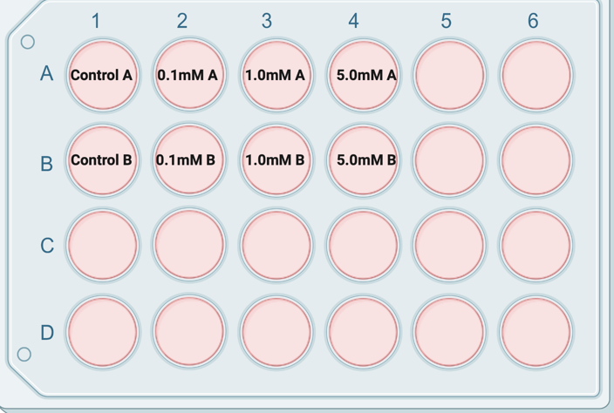
The EA.hy926 human endothelial cells (ATCC 2025) were cultured in Leibovitz's L-15 medium with 10% fetal bovine serum (FBS) and an antibiotic/antimycotic solution (10,000U of Penicillin G, 10,000 µg streptomycin sulfate per ml). The cell line used in this study were from human umbilical veins with a thioguanine-resistant clone of A549 by exposure to polyethylene glycol (ATCC 2025). The cells were stored in a T75 culture flask and kept at 37°C in an incubator. The cells were grown in the complete culture medium and subcultured when confluent growth was observed. The release of cells during subculturing was done by 0.5% trypsin-EDTA solution, limiting exposure time as much as possible to maintain cell viability.

Caffeine Solution Preparation
To investigate the effect of caffeine on cell migration and growth, we prepared caffeine stock solutions with varying concentrations. A 5 mM caffeine solution was prepared by dissolving approximately 0.016g of Anhydrous Sigma-Aldrich Caffeine Powder in 15 mL of complete media (Leibovitz’s L-15 supplemented with 10% FBS and Antibiotic/Antimycotic Solution). This stock solution was then serially diluted to prepare 1 mM and 0.1 mM caffeine solutions for experimental use.

Well Preparation
A sterile razor was used to mark the underside of 8 wells with a cross-shaped marking for imaging reference, ensuring imaging consistency. Each well was seeded with approximately 200,000 cells as per the lab protocol. The cells were incubated with 1 mL of complete growth media until they reached approximately 90-100% confluency. This process took about 4 days for all of the wells to reach confluence. When confluency was achieved, the cells were deemed ready for the scratch assay.

Scratch Assay
Following the well preparation, an autoclaved P1000 pipette tip was used to create a vertical scratch near the middle of the wells. The scratch was completed by vertically dragging the pipette’s tip across the bottom of the well in a single fluid motion. Proceeding each vertical scratch, the pipette tip was dipped into 70% ethanol solution and then rinsed with deionized water for sterilization and reuse. The same method was repeated for all wells. Once each of the 10 wells had been scratched, the cells were washed with 1 mL of phosphate buffered saline at a pH of 7.2. For the control, 1 mL of regular complete media was replaced with the cells. For the experimental wells, 1 mL of the wells’ respective complete media with differing caffeine concentrations were added (0.1mM, 1mM, 5mM). Figure 1. Schematic diagram of well plate set up with varying caffeine concentration.
Following the addition of media, the cells were imaged and replaced in the incubator.

Data Collection
All wells on the plate were imaged using an EVOS M5000 Imaging System at 0, 3, 6, 9, and 12-hours post-scratch. Duplicate wells were used for each condition to ensure consistency and replication of the results. Images of each well were captured using the cross-shaped marking as reference to ensure consistent localization of the image on the scratch. To measure the effects of caffeine on cell migration, a scratch area was measured at each time point using the imaging software.

Statistical Analysis
The gap length was compared to the initial scratch gap length width to identify the percentage of closure over time to create a healing percentage metric. To determine the cell migration, the velocity was also calculated based on the initial scratch length to determine the movement of the cells. Statistical analysis was performed using a three-way between-subjects ANOVA in JASP. Microsoft Excel was used to create graphs to visually represent the data. To determine the statistical significance of the treatments, the threshold value for p was used to declare statistical significance; it was p=0.05.

Results

Imaging
The representative sample images, summarized in Table 1, provide a comprehensive look at how caffeine affects endothelial cell migration during the scratch test, simulating wound healing. The control group showed a steady decrease in gap length from 700μm at 0 hours to 460μm at 12 hours, with an average velocity of 20.4μm/hr, demonstrating normal wound healing progression. In contrast, the 0.1mM caffeine sample exhibited slower healing, with the gap decreasing from 450μm to 285μm over 12 hours, averaging 14.4μm/hr.

Time (hr) | Control | 0.1mM Caffeine | 1.0mM Caffeine | 5.0mM Caffeine
0 | 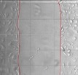  700μm | 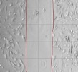  450µm | 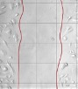  440µm | 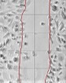  440μm
3 | 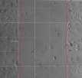  655μm | 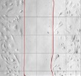  411μm | 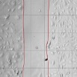  375μm | 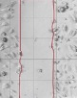  331μm
6 | 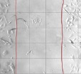  560μm | 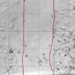  355μm | 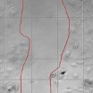  254μm | N/A
9 | 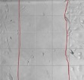  490μm | 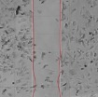  315μm | 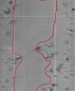  211μm | 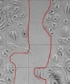  233μm
12 | 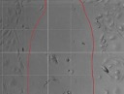  460μm | 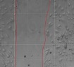  285μm | 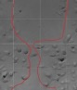  167μm | 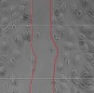  174μm
Figure 2. Sample representative images and quantification of wound closure migrated cells after the administration of caffeine at the indicated concentration for multiple timestamps.

Velocity
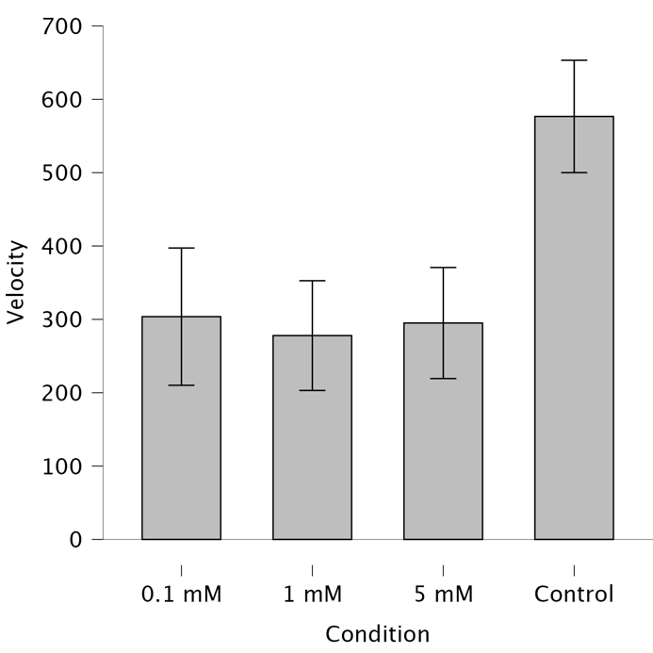
Interestingly, the 1.0mM caffeine sample showed slightly more efficient wound closure, with the gap narrowing from 440μm at 0 hours to 167μm at 12 hours, resulting in an average velocity of 25.2μm/hr. Similarly, the 5.0mM caffeine sample closed from 440μm to 174μm in the same period, with an average velocity of 27.0μm/hr. Both the 1.0mM and 5.0mM caffeine samples displayed unexpected growth patterns compared to the control, suggesting a non-linear relationship between caffeine concentration and wound healing efficiency.
Figure 3. Cell migration velocities for 0.1mM, 1.0mM, and 5.0mM experimental and control treatments.

Percent Healing
Percent healing of the scratch wound assay was also calculated and is summarized in Table 3. The control group exhibited the lowest average percent healing at 22.7% over the 12-hour assay. As caffeine concentration increased, the percent healing followed the same trend. The 0.1mM, 1.0mM, and 5.0mM caffeine samples all showed higher healing percentages than the control, at 24.1%, 42.8%, and 42.2%, respectively. Notably, despite the 0.1mM sample having the smallest slope value, its overall percent cell healing was still slightly higher than the control’s. Meanwhile, the 1.0mM and 5.0mM samples demonstrated a significant increase in healing percentage, reinforcing the trend of enhanced endothelial cell migration with higher caffeine concentrations.
Table 1. Average percent healing and velocity of cell migration in varying caffeine concentrations during scratch test assay.

 | Percent Healing (%) | Velocity (μm/hr)
Control | 22.7 | 20.4
0.1mM | 24.1 | 14.4
1.0mM | 42.8 | 25.2
5.0mM | 42.2 | 27.0

Relationships
Figure 3 illustrates the relationship between healing, measured by scratch wound distance (μm), and time (hours) for the control and three caffeine-treated samples. The control group follows a steep slope (y = -21.5x + 702), indicating accelerated healing, whereas the 0.1mM caffeine sample exhibits a gentler slope (y = -14.2x + 448.4), suggesting a slight inhibition of cell migration. Contrarily, the 1.0mM and 5.0mM caffeine samples display slopes comparable to the control (y = -23.667x + 431.4 and y = -21x + 417.6, respectively), suggesting an unexpected increase in wound closure efficiency. These results indicate that higher caffeine concentrations may enhance endothelial cell migration, contrary to the inhibitory effect observed at lower concentrations (Young et al. 2022).

Discussion
Findings
The scratch test assay we conducted investigated the effects of caffeine on the proliferation and migration of EA.hy926 endothelial cells. While our results showed trends suggesting greater scratch wound closure at higher caffeine concentrations over time, these differences were not statistically significant. Our findings contradict previous literature, all of which show that caffeine inhibits the migration and growth of endothelial cells in a scratch wound assay (Sheikpranbabu et al. 2010).
Sorenson et al. (2021) demonstrated that caffeine decreased choroidal endothelial cell migration, suggesting that caffeine inhibits cell migration. Further research showed that caffeine promotes endothelial apoptosis and suppresses angiogenesis (Ojeh et al. 2016). Through these studies, caffeine's ability to promote apoptosis and suppress angiogenesis are key indicators of how it negatively regulates wound healing and vascular regeneration in endothelial cells (Li et al. 2013; Sorenson et al. 2021; Ojeh et al. 2016).
Interestingly, while there was a trend demonstrating that higher concentrations of caffeine (5.0mM and 1.0mM) increased endothelial cell migration compared to lower concentrations, these differences were not statistically significant relative to the control. Although our data suggested a possible dose-dependent biphasic effect, where low caffeine concentrations inhibit endothelial cell migration while higher doses enhanced it, there was no statistical significance, and thus, interpretations should be made cautiously. This pattern is inconsistent with existing literature. This makes our findings interesting since low doses of caffeine inhibit endothelial cell migration while high doses stimulate it. However, these findings are incongruent with what is seen in the literature, suggesting that uncontrolled variables or experimental differences may have influenced our results.

Sources of Error and Limitations
Our results differ from those of previous studies for many potential reasons. A significant factor could be the differences in the tested endothelial cell lines; other studies used primary or choroidal endothelial cells (Sorenson et al. 2021; Ojeh et al. 2016). We could not find literature that identifies the effects of caffeine on a scratch wound assay, specifically using EA.hy926 cells. Thus, the cell type and origin differences may have caused our unique results.
Alternatively, multiple confounding variables could have impacted our study. For example, we cultured our cells in Leibovitz's L-15 medium. Other studies used different culture conditions, such as those of Ojeh et al. (2016), which affect caffeine interaction with endothelial cells.
Additionally, the concentration of caffeine used in our study was slightly different from that of other academic reports that used similar tests. Most scratch wound assays using caffeine had concentrations < 1mM, while our study included a much higher dose of 5.0mM. Further, the duration of exposure to caffeine and the time of our imaging limited the data we could collect.
While our study provides intriguing insights, there are many limitations. Firstly, we only analyzed migration for 12 hours, a relatively short period compared to other studies conducted by Sorenson et al. (2021) and Ojeh et al. (2016), who observed migration over 72-hour and 27-hour periods, respectively.
We also had data that focused solely on cell migration and did not consider cell proliferation assays, such as the MTT assay, to determine if caffeine affects cell division. Further, we did not follow up on our investigation with subsequent trials, limiting the viability of our results. Moreover, we could have compared the effects of caffeine on primary cell lines and the EA.hy926 immortal cell lines to validate whether the effects are physiologically relevant.

Future Work
Although our findings contradict the literature, the results suggest a possible trend that high-dose caffeine may enhance repair rate and cell migration in EA.hy926 endothelial cells. Further research analyzing the effects of caffeine on EA.hy926 endothelial cells is required to ensure consistency and accuracy of our results. If similar findings persist after multiple trials, the next step would be to test the process in vivo. Ultimately, if researchers identify enhanced cell growth by administration of high-dose caffeine in vivo, this could lead to the development of caffeine supplementation for wound healing and post-surgical recovery.

Conclusion
Our findings suggest a potential, but not statistically significant, trend where caffeine may enhance endothelial cell migration at higher concentrations (5.0 mM and 1.0 mM) and inhibit migration at lower concentrations (0.1 mM). These observations contrast with previous literature reporting inhibitory effects of caffeine on endothelial migration and angiogenesis. Given the lack of statistical significance in our migration and healing results, further research involving repeated trials and longer observation periods is necessary to validate these findings. Additionally, exploring the effects of caffeine on different endothelial cell types, proliferation, and in vivo wound healing remains an important future direction to better understand the physiological relevance of caffeine in vascular repair.

References

Adair TH, Montani J-P. 2010. Overview of Angiogenesis. In: Angiogenesis. Morgan & Claypool Life Sciences. [accessed 2025 Mar 21]. https://www.ncbi.nlm.nih.gov/books/NBK53238/.
Alberts B, Johnson A, Lewis J, Raff M, Roberts K, Walter P. 2002. Blood Vessels and Endothelial Cells. In: Molecular Biology of the Cell. 4th edition. Garland Science. [accessed 2025 Mar 21]. https://www.ncbi.nlm.nih.gov/books/NBK26848/.
Caffeine. CAMH. [accessed 2025 Mar 21]. https://www.camh.ca/en/health-info/mental-illness-and-addiction-index/caffeine.
Daly JW, Shi D, Nikodijevic O, Jacobson KA. 1994. The role of adenosine receptors in the central action of caffeine. Pharmacopsychoecologia. 7(2):201–213.
EA.hy926 - CRL-2922. ATCC. [accessed 2025 Mar 21]. https://www.atcc.org/products/crl-2922?nt=wobj-20-q#detailed-product-images.
Li H, Jin S-Y, Son H-J, Seo JH, Jeong G-B. 2013. Caffeine-induced endothelial cell death and the inhibition of angiogenesis. Anat Cell Biol. 46(1):57–67. doi:10.5115/acb.2013.46.1.57.
Ojeh N, Stojadinovic O, Pastar I, Sawaya A, Yin N, Tomic-Canic M. 2016. The effects of caffeine on wound healing. International Wound Journal. 13(5):605–613. doi:10.1111/iwj.12327.
Sheikpranbabu S, Ravinarayanan H, Elayappan B, Jongsun P, Gurunathan S. 2010. Retracted: Pigment epithelium-derived factor inhibits vascular endothelial growth factor-and interleukin-1beta-induced vascular permeability Endothelial Function. Current Vascular Pharmacology. 10(1):4-18. doi: 10.2174/157016112798829760.
Sorenson CM, Song Y-S, Zaitoun IS, Wang S, Hanna BA, Darjatmoko SR, Gurel Z, Fisk DL, McDowell CM, McAdams RM, et al. 2021. Caffeine Inhibits Choroidal Neovascularization Through Mitigation of Inflammatory and Angiogenesis Activities. Front Cell Dev Biol. 9. doi:10.3389/fcell.2021.737426. [accessed 2025 Mar 21]. https://www.frontiersin.org/journals/cell-and-developmental-biology/articles/10.3389/fcell.2021.737426/full.
Young BL, Sheppard ED, Phillips S, Stubbs TM, He JK, Moon A, Pinto MC, McGwin G, Brabston EW, Gilbert SR, et al. 2022. Caffeine intake does not appear to impair tendon-to-bone healing strength in a rat rotator cuff repair model. JSES International. 6(3):463–467. doi:10.1016/j.jseint.2021.12.011

Appendix
Supplementary Figures
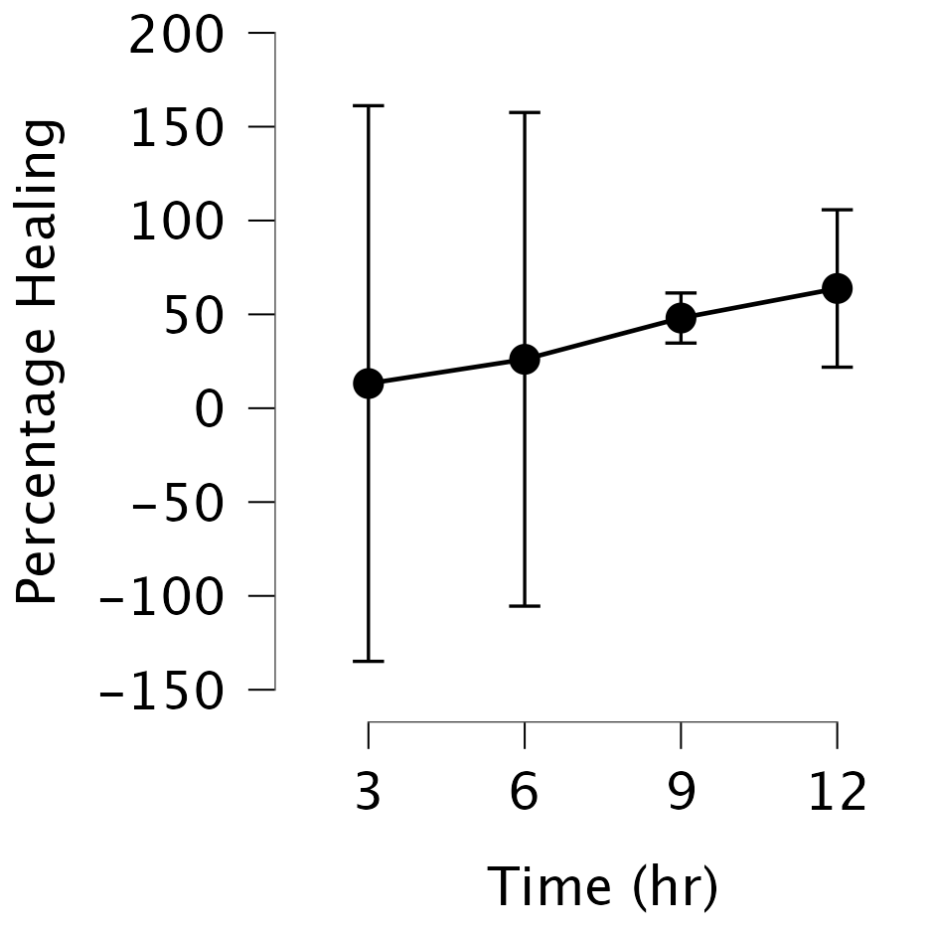
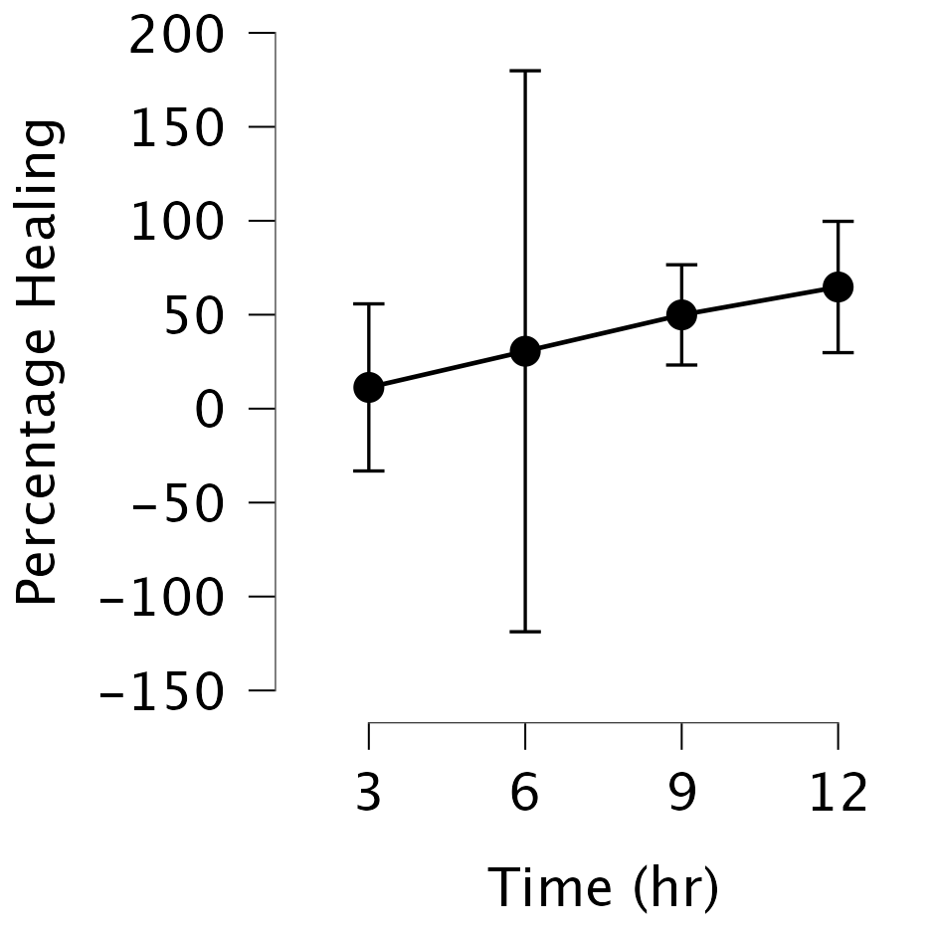
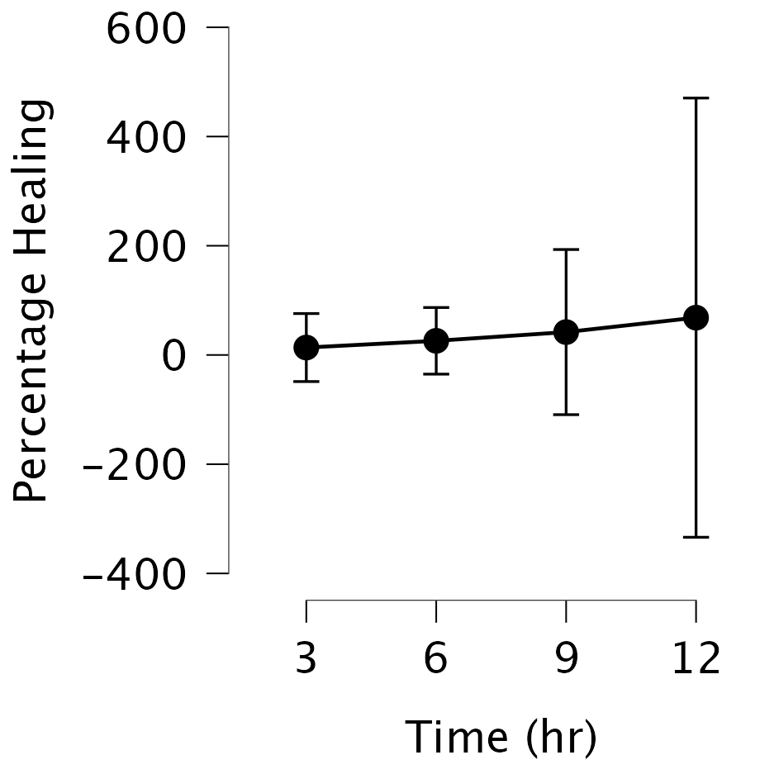
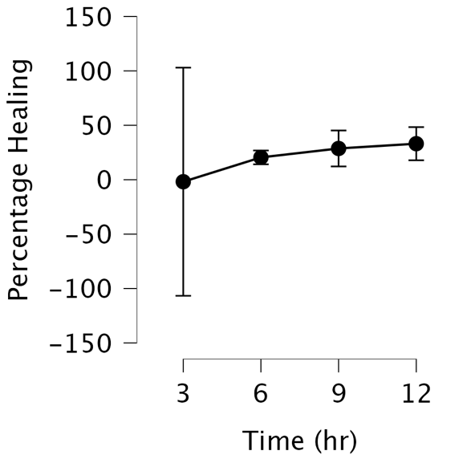
D
CC
A
B

Figure 5. Percentage healing over time for the control (A), 0.1mM (B), 1mM (C), and 5mM (D) treatments.
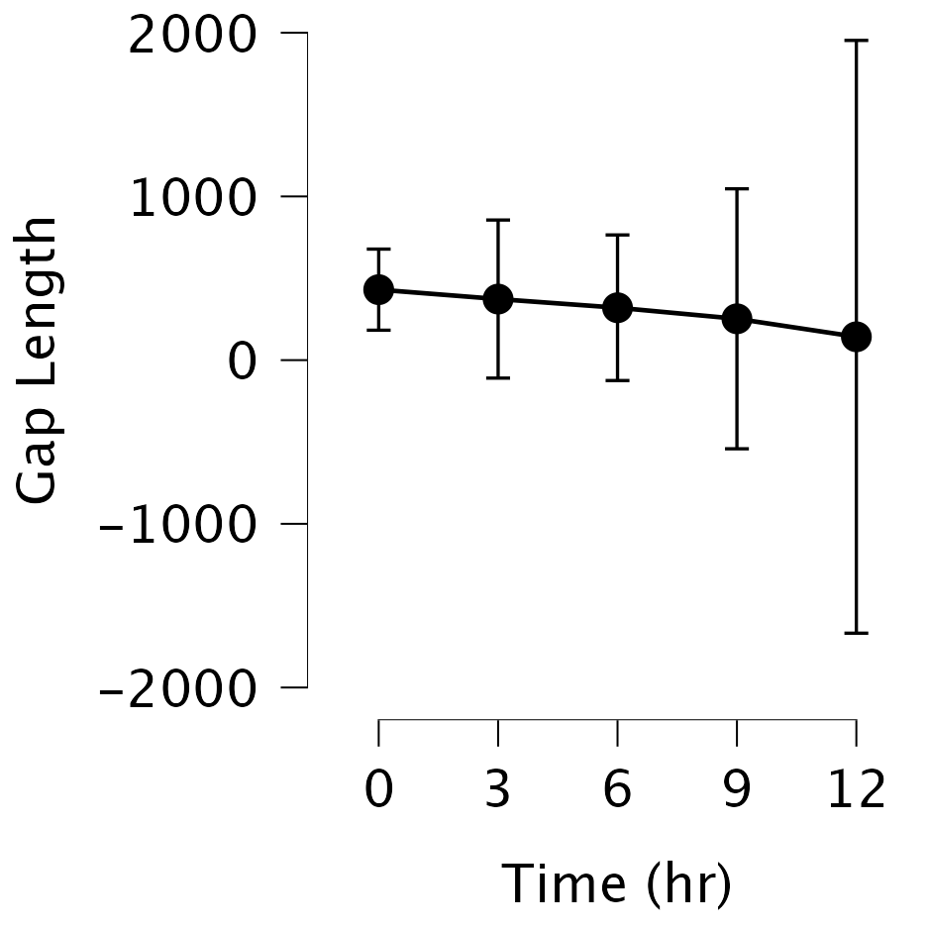
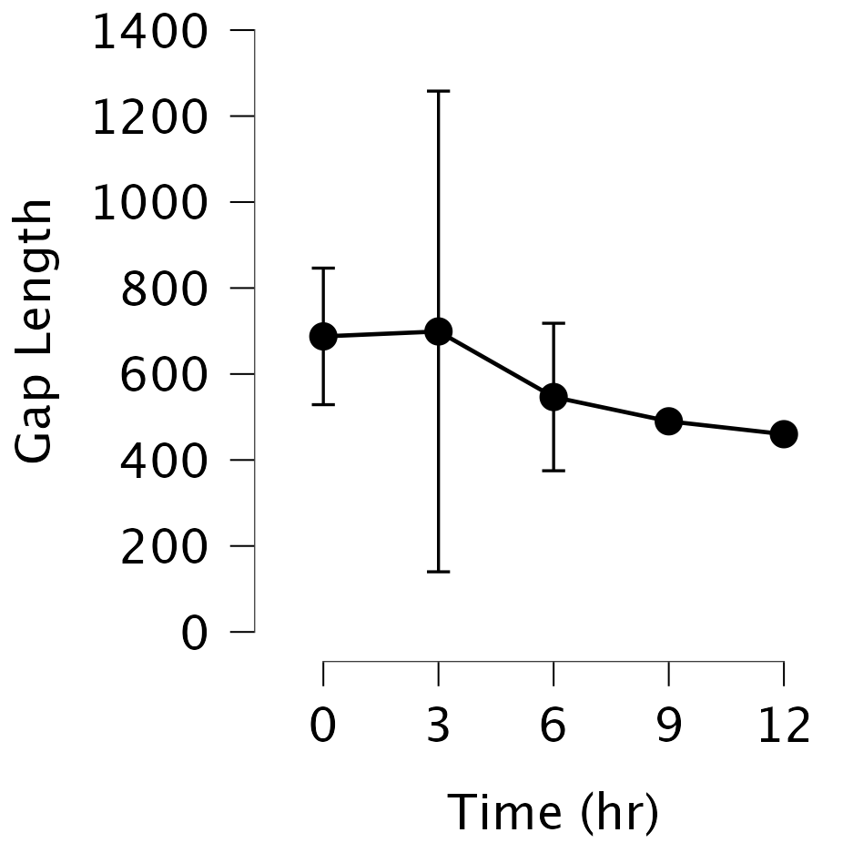
B
A
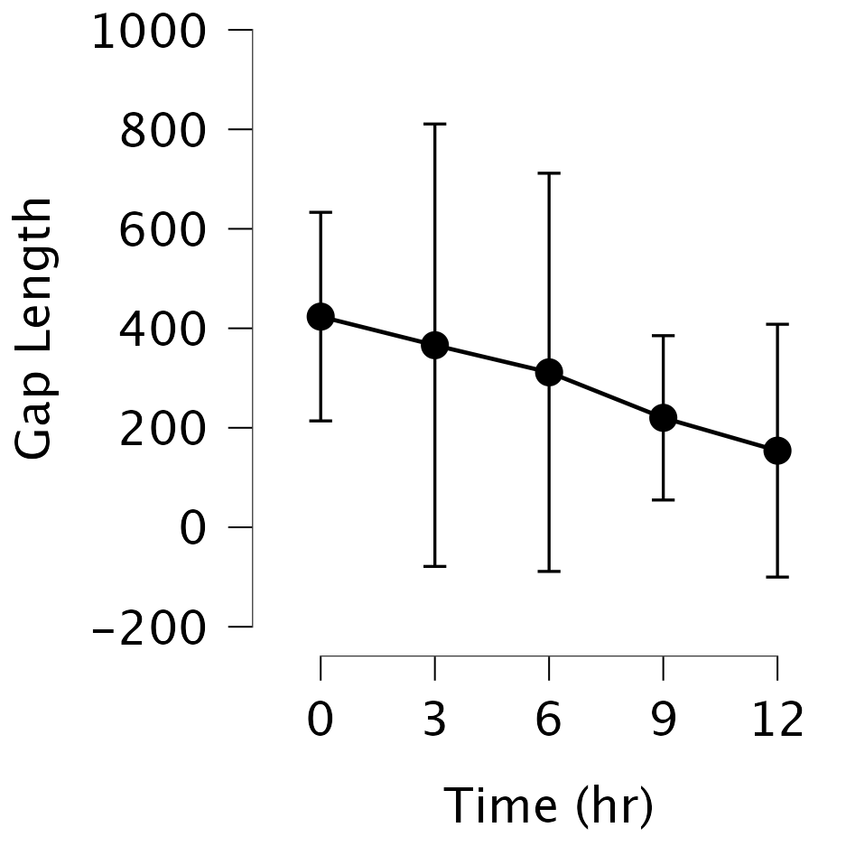
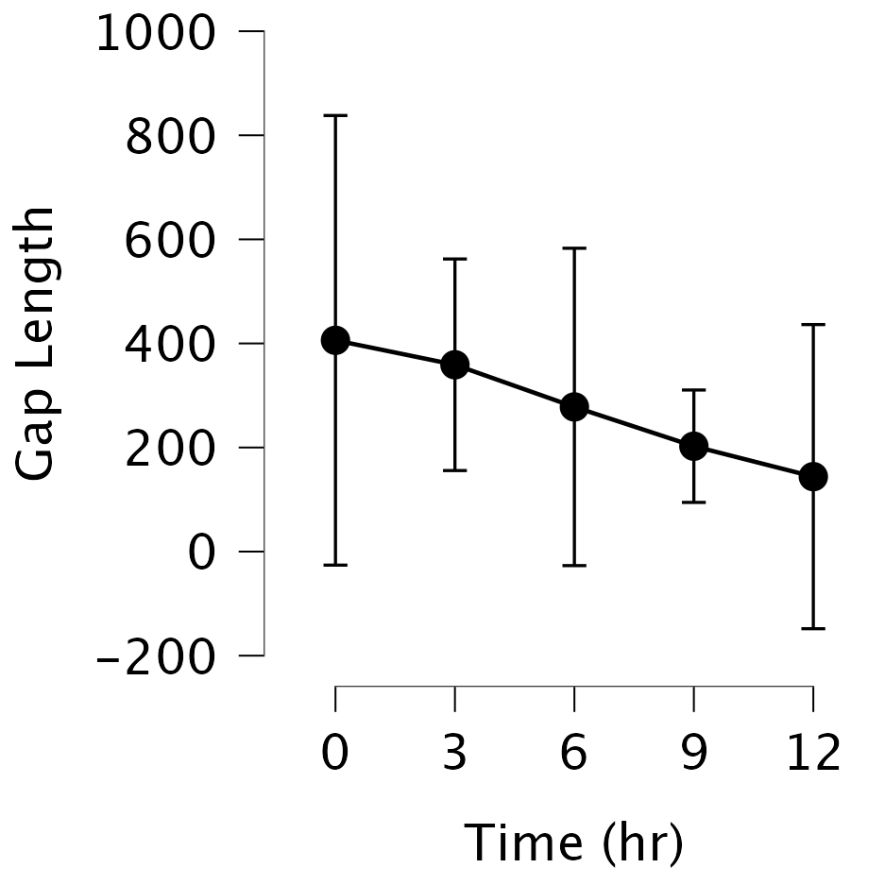
D
CC
Figure 6. Gap length over time for the control (A), 0.1mM (B), 1mM (C), and 5mM (D) treatments.

Statistics
Gap Length
Table 2. ANOVA statistics for gap length.
Cases |  | Sum of Squares |  | df |  | Mean Square |  | F |  | p
Time (hr) |  | 375537.650 |  | 4 |  | 93884.413 |  | 26.684 |  | < .001
Condition |  | 610071.000 |  | 3 |  | 203357.000 |  | 57.798 |  | < .001
Time (hr) ✻ Condition |  | 10397.750 |  | 12 |  | 866.479 |  | 0.246 |  | 0.992
Residuals |  | 70368.000 |  | 20 |  | 3518.400
Note. Type III Sum of Squares

Table 3. Descriptive statistics for gap length.
Time (hr) |  | Condition |  | N |  | Mean |  | SD |  | SE |  | Coefficient of variation
0 |  | 0.1 mM |  | 2 |  | 430.500 |  | 27.577 |  | 19.500 |  | 0.064
 |  | 1 mM |  | 2 |  | 406.000 |  | 48.083 |  | 34.000 |  | 0.118
 |  | 5 mM |  | 2 |  | 423.500 |  | 23.335 |  | 16.500 |  | 0.055
 |  | Control |  | 2 |  | 687.500 |  | 17.678 |  | 12.500 |  | 0.026
3 |  | 0.1 mM |  | 2 |  | 373.000 |  | 53.740 |  | 38.000 |  | 0.144
 |  | 1 mM |  | 2 |  | 359.000 |  | 22.627 |  | 16.000 |  | 0.063
 |  | 5 mM |  | 2 |  | 366.000 |  | 49.497 |  | 35.000 |  | 0.135
 |  | Control |  | 2 |  | 699.000 |  | 62.225 |  | 44.000 |  | 0.089
6 |  | 0.1 mM |  | 2 |  | 320.000 |  | 49.497 |  | 35.000 |  | 0.155
 |  | 1 mM |  | 2 |  | 278.000 |  | 33.941 |  | 24.000 |  | 0.122
 |  | 5 mM |  | 2 |  | 311.500 |  | 44.548 |  | 31.500 |  | 0.143
 |  | Control |  | 2 |  | 546.500 |  | 19.092 |  | 13.500 |  | 0.035
9 |  | 0.1 mM |  | 2 |  | 252.500 |  | 88.388 |  | 62.500 |  | 0.350
 |  | 1 mM |  | 2 |  | 202.500 |  | 12.021 |  | 8.500 |  | 0.059
 |  | 5 mM |  | 2 |  | 220.000 |  | 18.385 |  | 13.000 |  | 0.084
 |  | Control |  | 2 |  | 490.000 |  | 0.000 |  | 0.000 |  | 0.000
12 |  | 0.1 mM |  | 2 |  | 142.500 |  | 201.525 |  | 142.500 |  | 1.414
 |  | 1 mM |  | 2 |  | 144.000 |  | 32.527 |  | 23.000 |  | 0.226
 |  | 5 mM |  | 2 |  | 154.000 |  | 28.284 |  | 20.000 |  | 0.184
 |  | Control |  | 2 |  | 460.000 |  | 0.000 |  | 0.000 |  | 0.000

Healing Percentage
Table 4. ANOVA statistics for healing percentage.
Cases |  | Sum of Squares |  | df |  | Mean Square |  | F |  | p
Time (hr) |  | 233.436 |  | 3 |  | 77.812 |  | 0.460 |  | 0.714
Condition |  | 123.171 |  | 3 |  | 41.057 |  | 0.243 |  | 0.865
Time (hr) ✻ Condition |  | 987.171 |  | 9 |  | 109.686 |  | 0.648 |  | 0.742
Residuals |  | 2706.390 |  | 16 |  | 169.149
Note. Type III Sum of Squares

Table 5. Descriptive statistics for healing percentage.
Time (hr) |  | Condition |  | N |  | Mean |  | SD |  | SE |  | Coefficient of variation
3 |  | 0.1 mM |  | 2 |  | 19.150 |  | 8.697 |  | 6.150 |  | 0.454
 |  | 1 mM |  | 2 |  | 15.700 |  | 8.485 |  | 6.000 |  | 0.540
 |  | 5 mM |  | 2 |  | 19.150 |  | 24.254 |  | 17.150 |  | 1.267
 |  | Control |  | 2 |  | -3.850 |  | 26.658 |  | 18.850 |  | -6.924
6 |  | 0.1 mM |  | 2 |  | 12.050 |  | 5.303 |  | 3.750 |  | 0.440
 |  | 1 mM |  | 2 |  | 18.900 |  | 17.112 |  | 12.100 |  | 0.905
 |  | 5 mM |  | 2 |  | 18.200 |  | 12.021 |  | 8.500 |  | 0.660
 |  | Control |  | 2 |  | 29.150 |  | 8.273 |  | 5.850 |  | 0.284
9 |  | 0.1 mM |  | 2 |  | 12.800 |  | 3.111 |  | 2.200 |  | 0.243
 |  | 1 mM |  | 2 |  | 18.700 |  | 9.475 |  | 6.700 |  | 0.507
 |  | 5 mM |  | 2 |  | 19.050 |  | 5.586 |  | 3.950 |  | 0.293
 |  | Control |  | 2 |  | 14.050 |  | 13.081 |  | 9.250 |  | 0.931
12 |  | 0.1 mM |  | 2 |  | 14.800 |  | 1.414 |  | 1.000 |  | 0.096
 |  | 1 mM |  | 2 |  | 14.450 |  | 11.809 |  | 8.350 |  | 0.817
 |  | 5 mM |  | 2 |  | 14.150 |  | 11.384 |  | 8.050 |  | 0.805
 |  | Control |  | 2 |  | 11.250 |  | 12.374 |  | 8.750 |  | 1.100

Velocity
Table 6. ANOVA statistics for velocity.
Cases |  | Sum of Squares |  | df |  | Mean Square |  | F |  | p
Condition |  | 610071.000 |  | 3 |  | 203357.000 |  | 57.798 |  | < .001
Time |  | 375537.650 |  | 4 |  | 93884.413 |  | 26.684 |  | < .001
Condition ✻ Time |  | 10397.750 |  | 12 |  | 866.479 |  | 0.246 |  | 0.992
Residuals |  | 70368.000 |  | 20 |  | 3518.400
Note. Type III Sum of Squares

Table 7. Descriptive statistics for velocity.
Condition |  | Time |  | N |  | Mean |  | SD |  | SE |  | Coefficient of variation
0.1 mM |  | 0 |  | 2 |  | 430.500 |  | 27.577 |  | 19.500 |  | 0.064
 |  | 3 |  | 2 |  | 373.000 |  | 53.740 |  | 38.000 |  | 0.144
 |  | 6 |  | 2 |  | 320.000 |  | 49.497 |  | 35.000 |  | 0.155
 |  | 9 |  | 2 |  | 252.500 |  | 88.388 |  | 62.500 |  | 0.350
 |  | 12 |  | 2 |  | 142.500 |  | 201.525 |  | 142.500 |  | 1.414
1 mM |  | 0 |  | 2 |  | 406.000 |  | 48.083 |  | 34.000 |  | 0.118
 |  | 3 |  | 2 |  | 359.000 |  | 22.627 |  | 16.000 |  | 0.063
 |  | 6 |  | 2 |  | 278.000 |  | 33.941 |  | 24.000 |  | 0.122
 |  | 9 |  | 2 |  | 202.500 |  | 12.021 |  | 8.500 |  | 0.059
 |  | 12 |  | 2 |  | 144.000 |  | 32.527 |  | 23.000 |  | 0.226
5 mM |  | 0 |  | 2 |  | 423.500 |  | 23.335 |  | 16.500 |  | 0.055
 |  | 3 |  | 2 |  | 366.000 |  | 49.497 |  | 35.000 |  | 0.135
 |  | 6 |  | 2 |  | 311.500 |  | 44.548 |  | 31.500 |  | 0.143
 |  | 9 |  | 2 |  | 220.000 |  | 18.385 |  | 13.000 |  | 0.084
 |  | 12 |  | 2 |  | 154.000 |  | 28.284 |  | 20.000 |  | 0.184
Control |  | 0 |  | 2 |  | 687.500 |  | 17.678 |  | 12.500 |  | 0.026
 |  | 3 |  | 2 |  | 699.000 |  | 62.225 |  | 44.000 |  | 0.089
 |  | 6 |  | 2 |  | 546.500 |  | 19.092 |  | 13.500 |  | 0.035
 |  | 9 |  | 2 |  | 490.000 |  | 0.000 |  | 0.000 |  | 0.000
 |  | 12 |  | 2 |  | 460.000 |  | 0.000 |  | 0.000 |  | 0.000

